**PRACTICAL NO:-07**

**Python and MongoDB a. Connecting Python with MongoDB and inserting, retrieving, updating and deleting.**

Step 1: Install pymongo

In terminal:

pip install pymongo

**1)Insertion:-**

**CODE:-**

from pymongo import MongoClient

client=MongoClient("mongodb://localhost:27017/")

db=client["python_db"]

coll=db["emp"]

rec={"name":"Karan","age":21}

i=coll.insert_one(rec)

print(i)

p=coll.find()

for x in p:

    print(x)

**OUTPUT:-**



**Inserting multiple data:-**

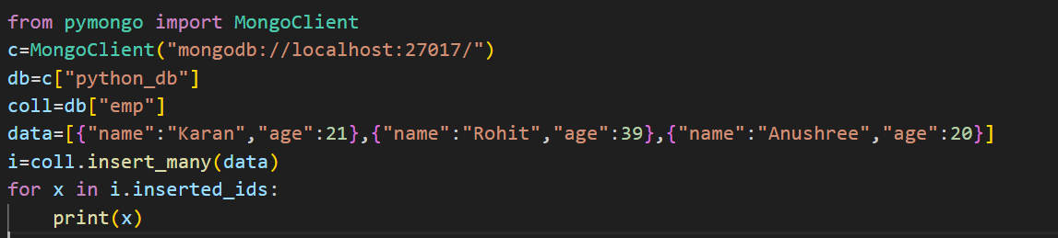

**OUTPUT:-**

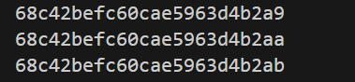

**Retrieving data:-**

**CODE:-**

from pymongo import MongoClient

c=MongoClient("mongodb://localhost:27017/")

db=c["python_db"]

coll=db["emp"]

r=coll.find_one({"age":21},{"_id":0})

print(r)

**OUTPUT:-**



**DELETE:**

**CODE:-**

from pymongo import MongoClient

c=MongoClient("mongodb://localhost:27017/")

db=c["python_db"]

coll=db["emp"]

r=coll.delete_many({"age":20})

for x in coll.find():

    print(x)

**OUTPUT:-**



**UPDATE**

**CODE:-**

from pymongo import MongoClient

c=MongoClient("mongodb://localhost:27017/")

db=c["python_db"]

coll=db["emp"]

r=coll.update_many({"name":"Karan"},{"$set":{"department":"IT"}})

for x in coll.find():

    print(x)

**OUTPUT:-**

